Jennifer Daniel

CIT480

Chapter 12 Exercises

**Exercise 12-1:**

12-1 Part 1/2:

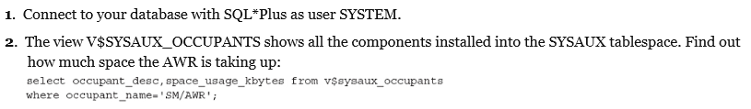

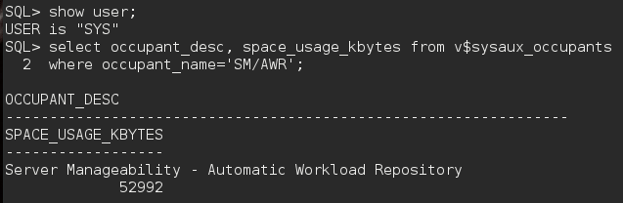

12-1 Part 3:





12-1 Part 4:



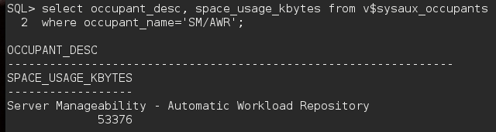

**#Size increase: 384**

12-1 Part 5:



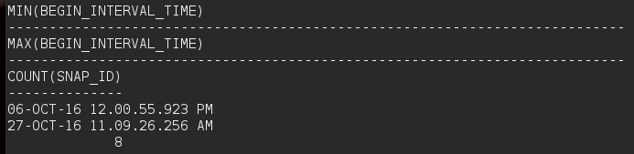

**Exercise 12-2:**

12-2 Part 1/2:

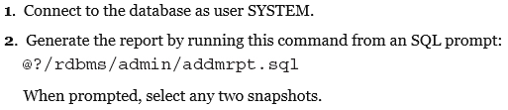

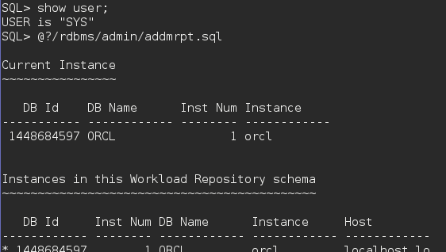

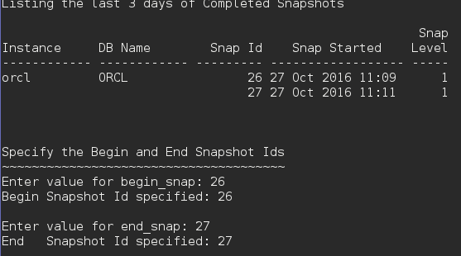

12-3 Part 3:



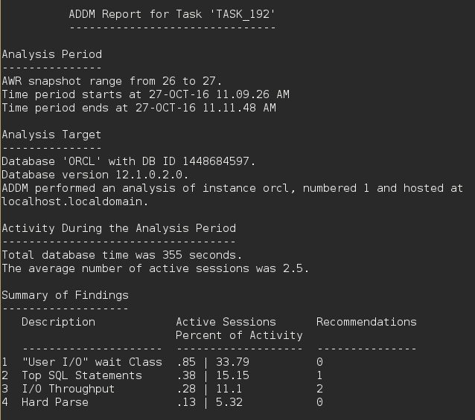

**Exercise 12-3:**

12-3 Part 1/2:

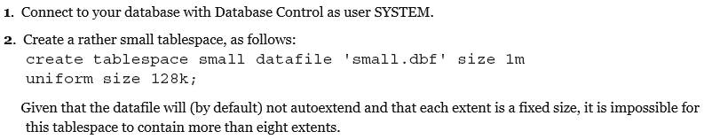

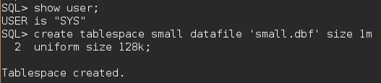

12-3 Part 3:

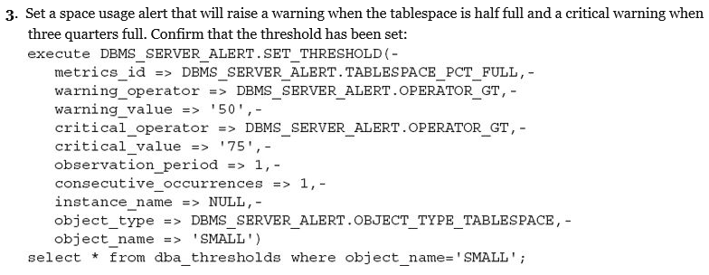

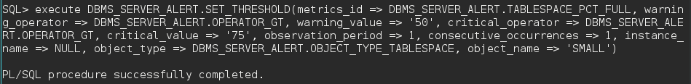

12-3 Part 4:





12-3 Part 5:





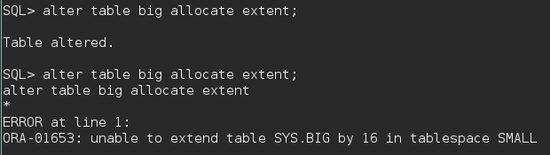

12-3 Part 6:

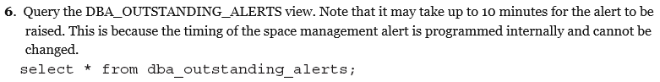

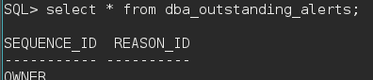

12-3 Part 7:



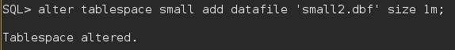

12-3 Part 8:

